REFORMING OF EDUCATIONAL PROCESS FOR LAW ENFORCEMENT BODIES IN ORDER TO ENSURE INFORMATIONAL SECURITY IN THE CONDITIONS
OF THE ANTI-TERRORIST OPERATION

OLEKSANDR KORYSTIN,
Rector of the Odessa State University
of Internal Affairs
Doctor of Law, Professor,
Colonel of Police

Abstract

The results of analysis of the reforming of the educational process in order to ensure informational security in the conditions of anti-terrorist operation are presented. Since last year Ukraine undergoes economic, energy, informational and a variety of other kinds of modern warfare. The most rich industrialized areas of Ukraine adjacent to the Russian Federation, became an arena of confrontation. They were chosen by terrorists and separatists as a base for destabilizing situation in the country. Due to this, the role of objective coverage of the counter-terrorist operation results and information security of the country increases significantly. Among the wide range of the means to prevent its proliferation, cooperation of law enforcement bodies of the state with the media during the counter-terrorist operations are really important. Research results and suggestions of the superior educational institution of the Ministry of Internal Affairs of Ukraine on the reform of the educational process in order to ensure information security in the anti-terrorist operation are covered.

Keywords: law enforcement, educational process, information security, information war, media coverage, anti-terrorist operation.

Recently the media often use the term "hybrid war", describing the situation in Ukraine. And we have to agree with this, in particular, with its component – the information war.
The two of the most rich, densely populated and industrialized areas of the country – Eastern regions of Ukraine, adjacent to the Russian Federation – Donetsk and Luhansk regions became the arena of confrontation. Namely they were chosen by terrorists and separatists as a base to destabilize the situation in the country. The essence of information warfare is "zombification" of the population of the Eastern regions of Ukraine and the obtrusion of distorted perception of real events through the media. In this context, a very important role belongs to objective information support of the results of the anti-terrorist operation and information security of the country.
As in any democratic European state, among the basic social values, in addition to ensuring the integrity and security of the person, the right to protection of life, health, honor and dignity and other guarantees, in the Constitution of Ukraine an important place belongs to protection of sovereignty and territorial integrity of the country, to ensuring its economic and information security. According to Art. 17 of our Constitution, it is one of the most important functions of the state and is the concern of all the Ukrainian people.
According to our Constitution and the criminal law, the establishment and operating of any armed formations, not envisaged by the law, are prohibited on the territory of Ukraine. For such actions, depending on the purpose of their implementation, a severe responsibility is supposed under the criminal law: in particular, Article 110 of the Criminal Code "Encroachment on territorial integrity and inviolability of Ukraine", Article 341 "Capture of state or public buildings or facilities", Article 255 " Creation of a criminal organization", Article 258 "Act of terrorism ", Article 260 "Creation of paramilitary or armed groups not envisaged by law", etc.
Protection of Ukraine, its sovereignty, territorial integrity and inviolability, are entrusted to the Armed Forces of Ukraine. In their turn, law enforcement, public safety and protection of the state borders of the country are assigned to the appropriate military units and law enforcement bodies of the state. The structure, organization and functioning of these bodies is determined by the relevant laws of Ukraine: "On the Police", "On Prosecutor's Office", "On Security Service", etc. According to these laws, with corresponding changes[], law enforcement authorities are obliged to inform the public on the state of the rule of law in Ukraine and on measures to strengthen it. In this regard, an important role in the realization of these democratic institutions belongs to media, that have a special legal status in Ukraine, special functions and important social assignment in society.
It should be noted that in recent years Ukraine faced with a problem that requires specialized knowledge in the field of information support not only of law enforcement in the broad sense, but also information support of anti-terrorist operations.
On our opinion, one of the ways to strengthen information security is the orientation of the educational process of higher educational institutions of the Ministry of Interior and other law enforcement agencies to providing basic knowledge on special regional characteristics of the country, on the understanding of the nature and place in the society of modern media, on varieties of of public opinion manipulating and on peculiarities of working with the media.
Primarily we shortly compare socio-criminological features of regions of Ukraine, according to a Diagram on Figure 1. According to the research carried out in the Odesa State University of Internal Affairs, stably complex crime situation used to be reported in the Donetsk and Luhansk regions over more than past 10 years. In these two regions annually there used to be committed about 20% of the total crime in the country[] and its individual types, such as: theft[], robbery[], murder[], recidivism[ ], juvenile crimes[], crimes committed by organized criminal groups and criminal organizations[], crimes in the area of drug trafficking[], etc..
FIGURE 1.
The Average Figures of Crime Structure in the Regions of Ukraine
for the Period 2001 – 2012.

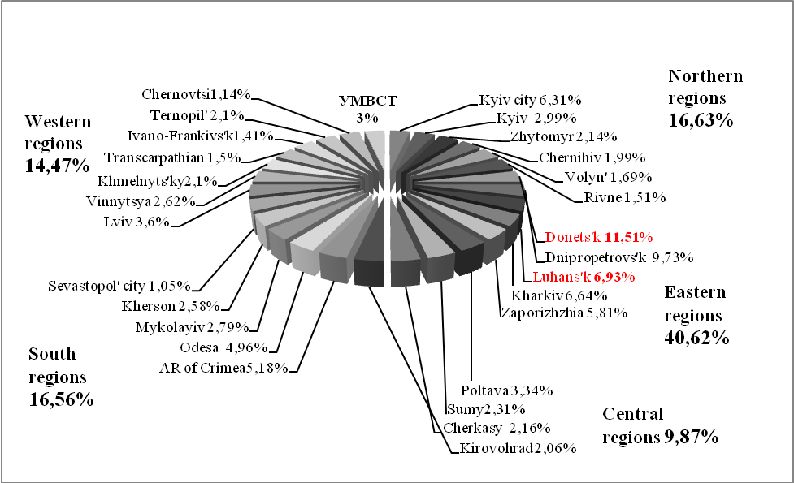

For understanding the specific features of these regions note that they are located in the East of Ukraine.
The boundaries of Donetsk and Lugansk regions with eastern neighbor make up to 40% of 2063 km of the total land border between Ukraine and the Russian Federation[]. Intensive development and industrial recovery of Donetsk area since 1950 was carried out with extensive use of prison labor^{[, p.176-177]}. Long-term problems of the region were laid already in those days, since a large number of prisoners demanded a certain amount of prisons. The negative heritage of the past lies in the fact that today 20 colonies for the execution of criminal punishment via imprisonment is concentrated in the Donetsk region, and 14 in Luhansk region. More than 20% of total number of prisoners in Ukraine are held in jails in these regions and each year are released and settled in the regions that creates significant crime-background in the regions and high level of contamination of large local population consciousness with "criminal subculture." This area traditionally keeps high level of common crime. It can be followed on a Cartogram depicted of Figure 2. This crime is often violent and mainly associated with consumption of alcohol or drugs.
FIGURE 2.
The Average Rate of Crime Per 10 Thousand Population in the Regions of Ukraine
for the Period 2001 – 2011.

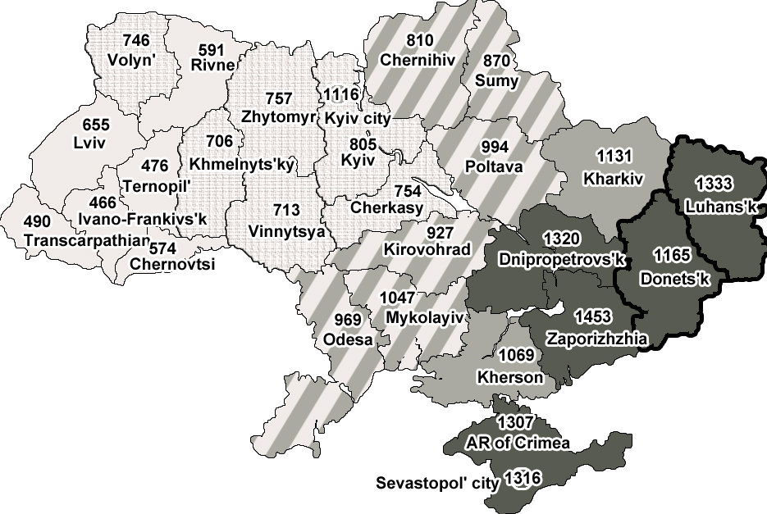
For the comparison, in the Western regions of the country the number of described institutions and the number of convicts is considerably lower, as lower is the level of the whole crime. For example, one colony is located in the Transcarpathian region, two in Chernivtsi region, Ternopil and Ivano-Frankivsk regions have four each^{[, p.13]}. And this despite the fact that the size of the territory in these regions is about the same, and the population is slightly lower than in the areas of Donetsk region. Of course, the situation described is a considerable criminological burden on the social and psychological environment in the Donetsk and Luhansk regions.
Besides, this is the most urbanized, densely populated Russian-speaking areas dominated by industrial mode of production, based on the extraction, processing and export of minerals, metal products, chemicals, etc.
The overwhelming majority of the population is involved in production associated with the use of harmful, heavy physical labor. However, long-term studies indicate that the aggression of masses is not a feature of the population of these territories. Its mentality is mainly focused on peaceful coexistence.. Psychology of the overwhelming majority of the local population is characterized by its affection to native land, positive, tolerant and friendly attitude towards others, respect and love for the work, the glorification of miners, metallurgists, chemists, law enforcement, military and navy. A distinctive feature of the population is also hospitality, respect for the nearest neighbors. The Football Championship "Euro 2012" and a number of international scientific, cultural and other activities are the bright confirmation of this. The range of interests is mainly linked to the decision of problems of family and work. However, mass psychology of a pretty big number of the population can be characterized by low social and political activity. A distinctive feature of this part of the population is low awareness of the benefits of the European lifestyle, high exposure to "deformed" values. However, a large proportion of the population have an increased tendency to impact on the consciousness of information influence, which awakes sense of patriotism, pride, responsibility for their land, fortitude in defense against aggression, etc.
From the above arises a reasonable question: what is the phenomenon of the events in Donetsk and Luhansk regions? The answer lies on the surface. In many ways, the incident is explained by a well-planned information aggression upon the minds of the local population, with the intent to deceive and attract a certain part of it to their side.
The results of our study reveal, that it is the above-described features of the region were actively used by illegal armed groups in the provocation of conflict in these areas. Well aware of the psychological characteristics of the local population, the separatists devoted a big role to information pressure on the consciousness of the population.
It is important to remember that the media, especially television and the Internet have become an integral part of the culture of modern society. It is the media creating an information background on which people, especially young people, generate a certain worldview as to the manner and lifestyle behaviors. In this context, the media have a huge opportunity, both of positive and negative impact on the consciousness, mood, and, as a consequence, the behavior of people.
The phenomenon of such an effect is that the impact of the media on people's minds is reflexive in nature, which causes involuntary, unconscious response to external or internal stimuli. As a rule, they are acquired as a consequence of repeated psychological impact, and by its very nature have the character of thoughts management.
For the understanding of information impact on mass public consciousness, we describe the nature and variety of information influence, used by counter-government forces, through manipulation. Manipulating the public opinion has recently become an independent technology. Thus it is not a coincidence that a large number of professionals, who exercise similar technologies, arose among unscrupulous news agencies. A whole system of training, research institutions, scientific and methodological literature came into being.^{[, p. 312-313]}.
Illegal groups always carry out manipulation with consciousness covertly. This deprives individuals of freedom to the greater extent than direct coercion, which often meets resistance. Victims of the impact in such circumstances are deprived the possibility of rational choice, as their free choice is blocked, and the desires and actions are programmed. In fact, it is a deprivation of fundamental human rights and freedoms, which is resulted in undermining all the foundations of European civilization. On this basis, one of the varieties of totalitarianism is being born – information dictatorship that turns a man into a programmed robot.
Methods for the consciousness manipulation being used by counter-state associations are generally known. Among them, the most frequent are a deliberate distortion of the real state of things; the understatement of some and the mainstreaming of other facts or events; substitution of facts by highlighting events that have occurred on another place or at another time; an outright lie via coverage of non-existent events, etc. The literature also highlights other ways of manipulating consciousness and hidden coercion which are being actively used by gangs and militias through: scam, bluff, demagoguery, intrigue, manipulation, disinformation, etc. Special techniques of "psychogenic", "psychoanalytic", "psychotropic" and other ways to influence the minds and behavior of people are also widely known.^{[, p. 150-151; , p.64-66]}.
Currently in Donetsk and Luhansk regions long time known ways of affecting the consciousness of the population are being used. In due time they were described in E.Toffler's "War and anti-ar." [].
In the course of their propaganda counter-state figures were widely using untrue types of information that have the most profound effect on the psyche of people: accusations of atrocities; exaggeration rates; demonization and dehumanization of the opponent; polarization; divine sanctions; meta-propaganda, which discredits the propaganda of the other side.
The specialists of the Odesa State University of Internal Affairs during their study of dynamics of the events in the Donetsk and Luhansk regions identified a number of well-designed stages of information influence on the minds of the local population by terrorists and separatists with extensive use of entire range of untruthful information methods.
The first of them is the preparation, let's call it "mass-meeting phase." The main objective of this phase is a criminal swinging of the society and deregulation of social environment within the region. Its point was that the professional demagogues and provocateurs organized power and information provocations on all kinds of public events: sporting, cultural, national, etc. In the course of such actions pro-Ukrainian views of the local population in the regions were suppressed by force, information activities to discredit the legitimate authorities and to demoralize the law enforcement agencies were carried out actively. For such activities radically-minded youth, persons previously convicted, alcohol and drugs addicts, as well as citizens without primary occupation were involved for financial reward. After such events false information used to be injected into the society and the foreign media with aim of information destabilization in the regions and disseminating anti-government sentiment among the population. Criminal elements pumped into the community atmosphere of imaginary threat from the authorities.
The second stage is the physical seizure of the premises of radio and TV broadcasting, active involvement of marginalized layers of population – the unemployed persons, leading an idle life, persons released from prisons, etc. – to the side of the separatists for financial reward. All this was accompanied by unplugging state TV and radio channels. Total "zombification" of mass consciousness of the population was made. The illusion of a large number of regions' people commitment to other – non-Ukrainian culture, to belonging to the number of selected people and to a special mission in the region was created.
The third stage was an aggressive power and information intraregional confrontation. It was characterized by the seizure of the premises of legitimate public authorities and law enforcement agencies, military units, etc. In parallel, the recruitment and arming of criminal elements among the population depressed, economically failed territories of the regions were carried out through the captured media. Such actions were carried out under the banner of protecting the region from the "external threat" and were accompanied by promises of material rewards. A distinctive feature of this period was the increase in the number of armed attacks on dealers, banks, collector cars with the money, the offices of enterprises, commercial establishments and citizens. This activity was accompanied by a parallel information imposing to the society the enemy image in the face of representatives of legitimate authorities, affluent segments of the population and law enforcement bodies.
The fourth stage is information propaganda with simultaneous creating of enemy image of the most of the civilian population, which maintains the integrity of the state. In parallel discredit of local and central government authorities was carried out with simultaneous provocation of military conflict. During this period, psychological attitudes of dangers and threats by the central authorities and the population of other regions of Ukraine were implanted through the captured media. Mass actions of intellectuals, artists, educated youth and the middle class were brutally suppressed. Information about these events was covered as an activity of provocateurs and traitors who want to destabilize the region.
The fifth stage was the "local referendum" in order to create an illusion of "legitimacy" of the self-proclaimed bodies. The process of this action was covered in a favorable light for anti-state elements with simultaneous blockage of the state media sources.
The sixth stage was active warfare against the representatives of the anti-terrorist operation. At this stage the activities of terrorists were characterized by sabotage aimed at the destruction of homes and means of communication, the killing of civilians. Population was falsely informed that this atrocities had been committed by the Ukrainian army. The main purpose of this was awakening patriotic feelings among the local population with the simultaneous coverage of the results of these events in Russian and other foreign media.
The dynamics of the events indicate that at the initial stage of the anti-terrorist operation Ukrainian authorities were losing the information war with the enemy. This mainly concerned the timeliness, scope and quality of information available to the public. Gradually, however, the bodies responsible for information support of the anti-terrorist operation soberly assessed the situation, identified the main forms, methods and techniques of subversive information activities. As a result, the basic plots and directions of information policy of the enemy have been identified. A series of events that eventually blocked the dissemination and perception by the Ukrainian population of separatist propaganda has been carried out.
In this regard, it is extremely necessary to deepen research on educating modern representatives of government and law enforcement agencies on the use of the media to counter crime and threats related to information security. Certainly an important task here is to expand the technical capabilities of government and law enforcement agencies on the use of the media, improvement of the legal framework governing the subjects of information activities. However, on our mind, the development of special techniques, guidelines and training programs aimed at improving information security in terms of anti-terrorist operations are also of a considerable importance.
The positive experience of the Odessa State University of Internal Affairs, where a unique, one-of-Ukrainian project "School of criminal journalism" is implemented since 2006, can serve as a basis for such methods. [].
Initially, the purpose of the training was to train journalists the basics of law in the area of criminal and civil law, criminal procedure, criminology, etc. But over time, it was understood that also law enforcement officials required some knowledge in the field of media work. This year, the target training session was completely focused on training spokespersons of our region, cadets, students and practitioners of law enforcement agencies basic knowledge concerning journalism and features of media work. A global goal is to provide law enforcement agencies the necessary knowledge for quality work with the media in the information confrontation, ensuring society of complete and accurate information on current events, the role of law enforcement agencies in informing the public about the state of law and order in the country.
The essence of education is that with the help of representatives of press services of regional departments of the Ministry of Internal Affairs, the Prosecutor's Office, the Odessa regional organization of the National Union of Journalists with the participation of the faculty of the University practitioners of law enforcement agencies are trained to obtain experience in media coverage of the performance of law enforcement agencies. The curriculum has been designed in the way that the accumulated educational and methodical arsenal can be successfully used in the preparation of specialists for work in the course of the anti-terrorist operation.
In this regard, as the primary goals of reforming of the educational process we consider improving the quality of interaction between law enforcement agencies and the media, research of new, more optimal forms and methods of information activities, monitoring information space, providing effective results of respect and protection the rights and freedoms of a person and a citizen, strengthening of law and order in the state, as well as counteraction to counter-state information activities during the anti-terrorist operation.
By the end of training the University issues a special certificate.
The main objectives on the way to achieve these goals were:
1) the development of law enforcement cooperation with the media, especially in the conditions of the anti-terrorist operation;
2) improving the efficiency of public and private media;
3) improving the organizational support of interaction with the media.
4) training of practitioners effective interaction with the media.
Achievement of these objectives implies a work on the following areas:
1) the research and active implementation of advanced forms and methods of interaction with the media (including of anti-terrorist orientation) into educational process of law enforcement bodies;
2) the development of a strategy of work with media on coverage of law enforcement performance;
3) the research of features of the media functioning in a city and in a region, the specifics of the main activities of journalists: reportage, interview, investigative journalism, etc.;
4) the study of legal aspects of interaction of journalists with law enforcement: peculiarities of obtaining and coverage information, psychological methods to establish contact with leaders of different character types, rank, etc.;
5) the development of mutually beneficial cooperation between law enforcement agencies and the media on implementing the experience of law enforcement themes coverage, enhancement of information support during the anti-terrorist operation;
6) familiarization with positively proven techniques of media appearances on forming of patriotism, raising legal awareness of citizens and on educating the population on active citizenship in the prevention of terrorism and other illegal activities;
7) implementation of educational technologies of public speeches of practitioners on media coverage of the anti-terrorist activities results;
8) submission to the law enforcement authorities proposals on traineeship of law enforcement staff in the press service of law enforcement in order to enhance the experience of public speaking.
During the classes the fostering the skills on compliance with a number of mandatory rules in the course of coverage of events related to the anti-terrorist operation was emphasized. Among the most important were these:
1) the media management is obliged to inform headquarters of the anti-terrorist operation of their intention to cover the events;
2) persons covering the events must carry and produce on demand editorial certificate or other proof of identity and their professional identity;
3) on obtaining the information about impending terrorist attack or its beginning, the journalist is obliged to inform his superiors before the promulgation of information received.
Summarizing, we note that the media in the modern world play an important role in the society. They have great information opportunities, including in combating crime, separatism, terrorism and other negative phenomena. In this regard, there is a need law enforcement officials to obtain basic knowledge on dealing with the media. Also, there is an urgent need to develop special techniques, guidelines and curriculums aimed at improving information security in terms of anti-terrorist operations and in general in the fight against crime. Appears necessary to make a proposal on the need to reform the educational process of law enforcement bodies through the implementation of advanced methods and techniques of interaction with the media, particularly of anti-terrorist orientation.

Закон України «Про внесення змін до деяких законів України щодо інформування керівниками правоохоронних органів громадськості про стан законності та заходи щодо її зміцнення»//Відомості Верховної Ради України (ВВР). – 2010. – N 37. – ст.497
Бабенко А.М. Кримінологічна класифікація регіонів України та її значення для протидії злочинності/А.М.Бабенко//Бюлетень Міністерства юстиції України. – 2013. – №3 (137). – С.116-123.
Бабенко А.Н. Территориальные особенности распространения краж (украинский опыт исследования)/ А.Н. Бабенко// Труды академии Министерства внутренних дел Республики Таджикистан [научный журнал]. – 2013. – № 1 (19). – С. 54-59.
Бабенко А.М. Насильницька злочинність в регіонах України: деякі кримінологічні особливості/А.М. Бабенко// Проблеми правознавства та правоохоронної діяльності. – 2013. - №2 (53). – С.90-98.
Бабенко А.М. Кримінологічні особливості умисних вбивств та замахів на вбивства в регіонах України/А.М. Бабенко// Верховенство права та правова держава [матеріали міжнародної науково-практичної конференції, м. Ужгород, 18-19 травня 2013р.]. – Херсон: Видавничий дім «Гельветика», 2013. – С.138-141.
Бабенко А.М. Регіональні особливості рецидивної злочинності в Україні/ А.М.Бабенко// Науковий вісник Херсонського державного університету. – Серія «Юридичні науки». – 2014. – Випуск 3. – Том 3 – С.14-20.
Бабенко А.М. Географія злочинності неповнолітніх: що очікує Україну через 10 років?/А.М.Бабенко// Порівняльно-аналітичне право. – 2013. – №3-1. – С. 296-300. – Режим доступу:http://www.pap.in.ua/3-1_2013/8/Babenko%20A.M..pdf. – Назва з екрану.
Бабенко А.М.Кримінологічні особливості злочинності організованих груп і злочинних організацій в регіонах України/А.М.Бабенко//Актуальні проблеми протидії організованій злочинній діяльності [матеріали Всеукраїнської науково-практичної Інтернет конференції (м. Одеса, 26 вересня 2014 року)]. – Одеський державний університет внутрішніх справ. – Одеса, 2014. – С.11-14
Бабенко А.М. Регіональні особливості розподілу наркозлочинності в Україні: деякі шляхи протидії/ А.М. Бабенко// Науковий вісник Ужгородського національного університету. – Серія «Право». – 2012. – Випуск 20. – Частина 1. – Том 4. – С.12-14.
Бабенко А.М. Шляхи вдосконалення запобігання злочинності в прикордонних регіонах України/А.М. Бабенко// Південноукраїнський правничий часопис. - 2014. - № 3. – С. 16-18
Филонов В.П. Преступность в особо крупном промышленном городе: состояние, причины и меры по ее предупреждению[монография]/В.П. Филонов, Д.В. Федоренко. – Донецк:ДИВД МВД Украины, 2002. – 281 с.
Бабенко А.М. Вплив кримінальної субкультури на злочинність в регіонах України/ А.М. Бабенко// Науковий вісник Ужгородського національного університету. – Серія «Право». – 2013. – Випуск 22. – Частина II. – Том 3. – С.12-15.
Сулацкий Д.В. Негативні інформаційні впливи на споживачів телекомунікаційних послуг/Д.В. Сулацький// Боротьба з правопорушеннями в молодіжному середовищі: вітчизняний та міжнародний досвід [матеріали міжнародної науково-практичної конференції (м. Донецьк, 2 червня 2010 року)]. – Донецьк: Донецький юридичний інститут ЛДУВС ім. Е.О. Дідоренка, 2010. – c.312-315
Горбулин В.П. Інформаційні операції та безпека суспільства: загрози, протидія, моделювання:[монографія]/В.П. Горбулін, О.Г. Додонов, Д.В. Ланде; ІПНБ при РНБОУ. – Київ: Інтертехнологія, 2009. – 164 с.
Основы информационной безопасности:[учебное пособие для вуов]/ Е.Б.Белов, В.П. Лось, Р.В. Мещеряков, А.А.Шелупанов. – Москва: Горячая линия – Телеком, 2006. – 544 с.
Toffler A. and H. War and anti-war. Survival at the dawn of the 21st century. — London, 1993
В ОДУВС готують прес- секретарів: [Електронний ресурс]. – Режим доступа: //www.oduvs.edu.ua/news/567-v-oduvs-gotuyut-pres-sekretarv.html. – Название с экрана.

